**University of Michigan – Dearborn**

**CIS 200 – Computer Science 2**

**Lab# 4**

Quan Le

[lmmquan@umich.edu](mailto:lmmquan@umich.edu)

October 15, 2024

**Table Content**

Contents

Question 1 3

Source Code 3

Description 3

Structures 3

Screenshots 3

UML Diagram 4

Testing 5

# Question 1

## Source Code

The source code for this question has been uploaded to Canvas as Lab_4.cpp.

## Description

This program implements and demonstrate fundamental operations on linked list such as insertion, deletion, retrieval and display

## Structures

* Define a Node class with value and Node* next
* Define a LinkedList class with Node head

## Screenshots

Testing case 1

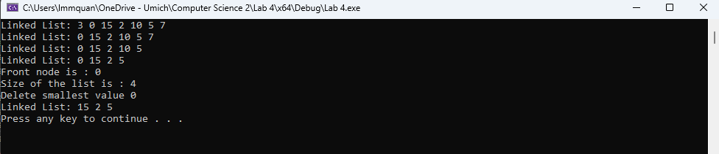

Testing case 2

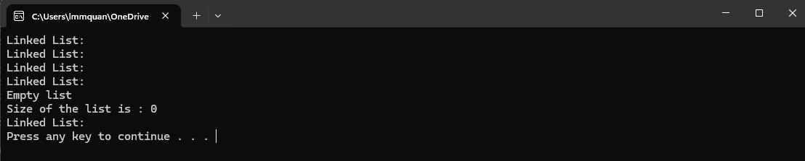

# UML Diagram

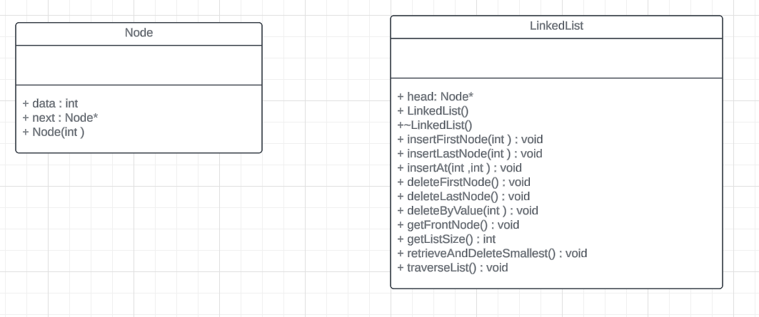

# Testing

|  |  |  |  |  |
| --- | --- | --- | --- | --- |
| Test # | Input value | Expected output | Actual output | Test Pass/Fail |
| 1 | Insert front node : 2,3  Insert last node : 5, 7  Insert node 10 at 3  Insert node 0 at 0  Insert node 15 at 3  ->Output  Delete first node  ->Output  Delete last node  ->Output  Delete by value 10  ->Output  Get front node  Get list size  Retrieve and delete the smallest entry  ->Output | 3 0 15 2 10 5 7  0 15 2 10 5 7  0 15 2 10 5  0 15 2 5  Front node is 0  Size of the list is 4  Delete smallest value 0  15 2 5 | 3 0 15 2 10 5 7  0 15 2 10 5 7  0 15 2 10 5  0 15 2 5  Front node is 0  Size of the list is 4  Delete smallest value 0  15 2 5 | Pass |
| 2 | **No insertion**  ->Output  Delete first node  ->Output  Delete last node  ->Output  Delete by value 10  ->Output  Get front node  Get list size  Retrieve and delete the smallest entry  ->Output | Output linked list but there is no node in the list  Empty list  Size of the list is 0 | Output linked list but there is no node  Empty list  Size of the list is 0 | Pass |